How Trade the MES off the ES 2000 Tick chart on NinjaTrader. (This works for both version 7 &8)
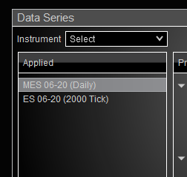
1. Create a new chart with the MES using a Daily chart
2. In the same Data Series add a new ES 2000 tick chart.

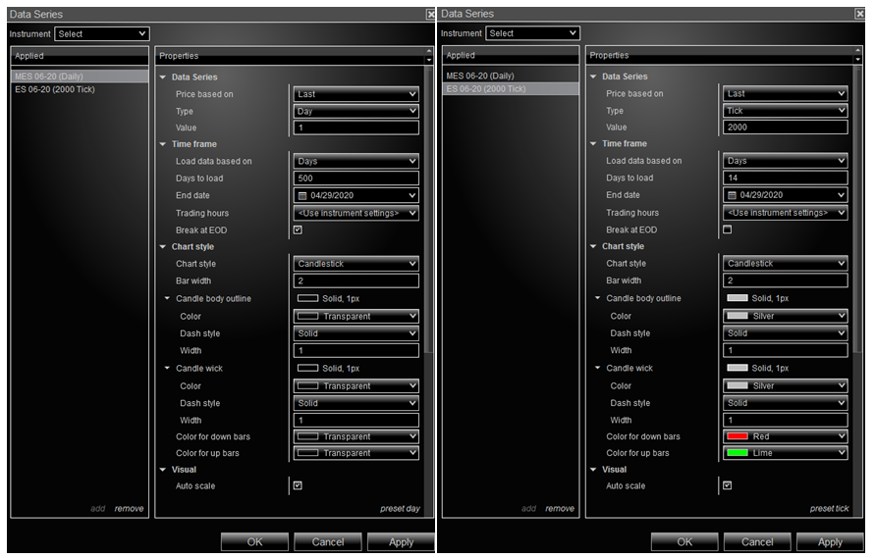
3. Important: Make the candle body, wick & body colors transparent only on the MES chart.
4. Click Apply & Ok.

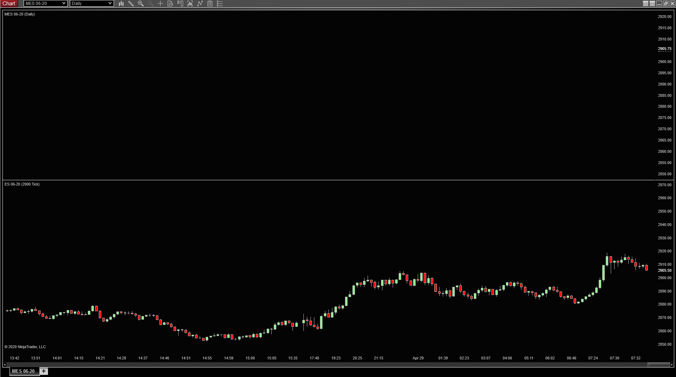
5. You will see a chart with two panes. The top will be a blank/transparent MES Daily. On the bottom you'll see an ES 2000 tick.

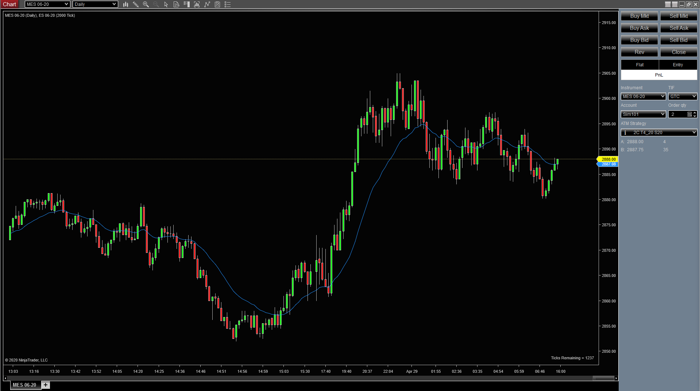
6. Click on any of the candles in the ES chart and drag them up to the blank MES Chart. This will combine the 2 chart. The MES will be the primary chart. When you open Chart Trader it will be from the MES chart
7. To add the 21 EMA, add indicator and then select the ES 2000 tick in the indicator Input Series box. Click Apply and Ok.
8. Do this for any indicator you want on your chart.

